Univatriate analyais:
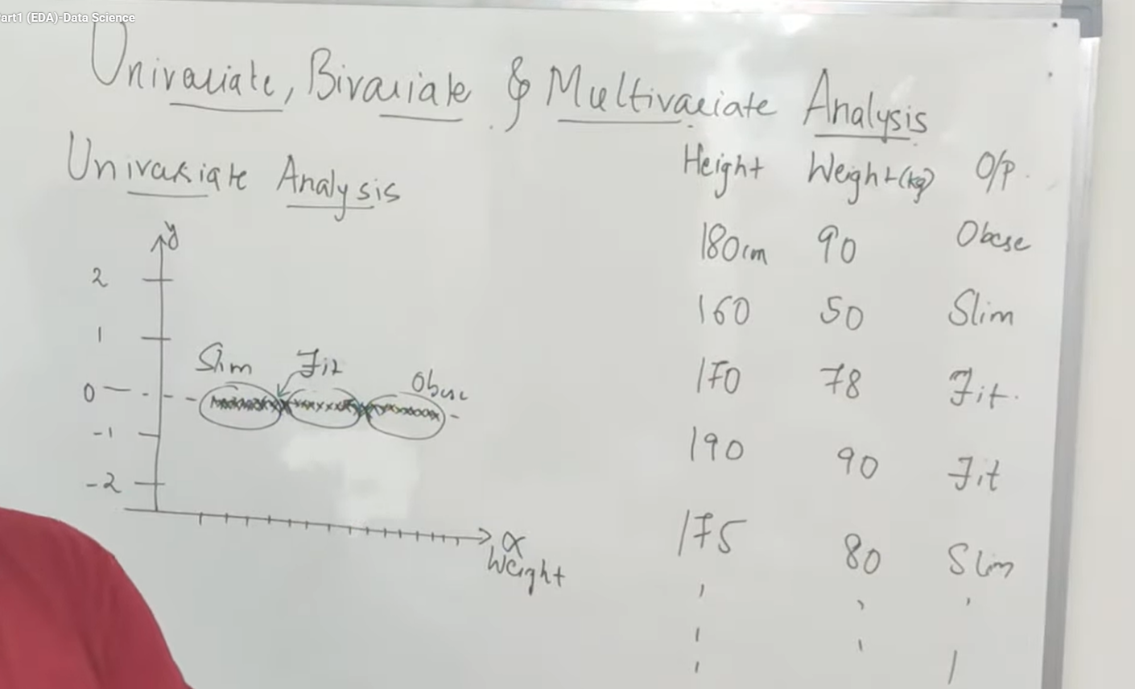
Easy to create histogram
Only one variable is used
Used in simple analysis

Bivariate analysis
Using to feature we understand the outliers
We can find which ml algorithms can be used
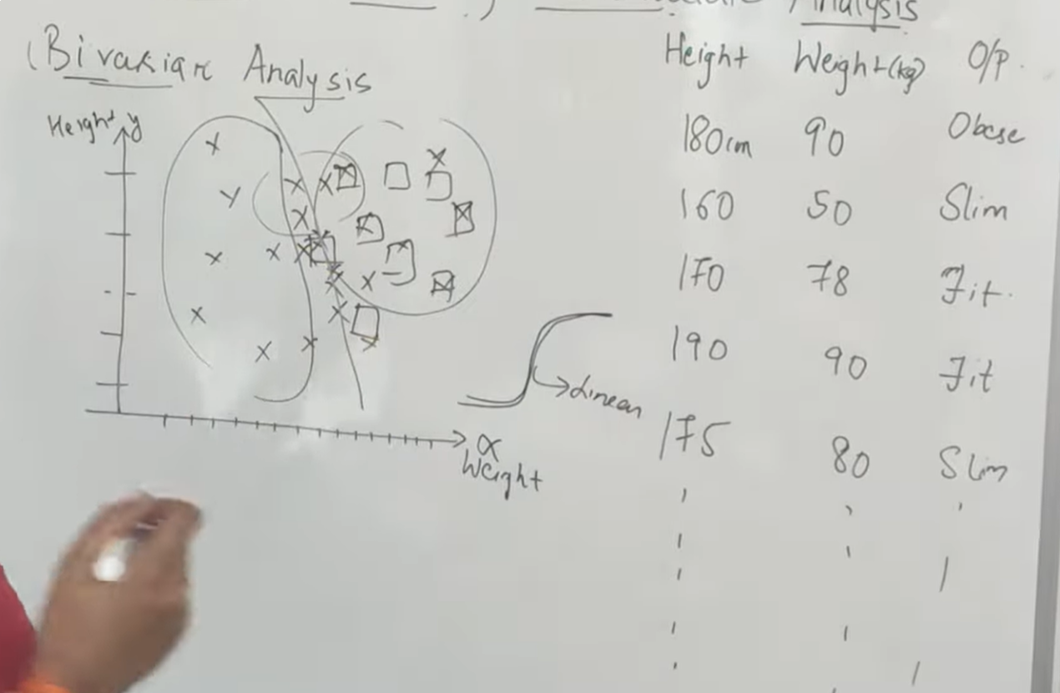

Multivariate Analysis

If me have more than 3 features we use multivariate analysis because we human beings cant see more than 3d diagrams
Seaborn is used to multivariate analysis
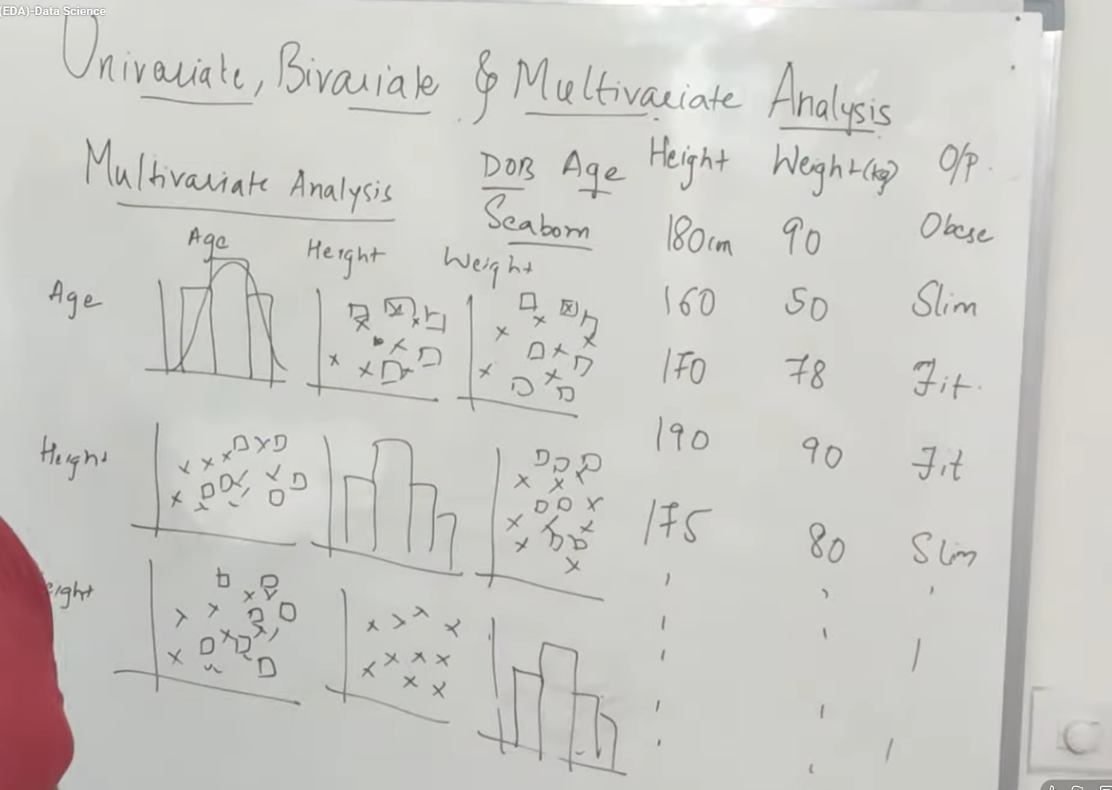
We find corelation out of it
We can get more info about the data set using the multivariate analysis with the help of seaborn

